Feature image: "Explore Greensboro’s Custom Jewelry Scene—Find Out More!"

Title: Why Greensboro Is a Hub for Custom Jewelry Enthusiasts
Focus Keyword: custom jewelers greensboro
Secondary Keyword:
jewelers greensboro nc
Diamond jewelers Greensboro NC
greensboro jewelers

Internal link:
Best jewelry store in greensboro: https://crystaljewelersnc.com/
Necklaces and Chains: https://crystaljewelersnc.com/necklaces-chains/

Meta Description:
Greensboro shines as a custom jewelry hub thanks to skilled artisans, quality materials, and shops like Crystal Jewelers, creating unique, personalized pieces.

Why Greensboro Is a Hub for Custom Jewelry Enthusiasts
North Carolina is best known for picturesque sceneries as well as historical beauty. But for custom jewelry enthusiasts, Greensboro, NC, offers something uniquely special. In this blog, we will explore the different reasons that make this lively city a popular attraction for sophisticated jewelry shoppers. If you need an original jewel or a diamond necklace, chains or anything else, Custom Jewelers Greensboro should be your next shopping destination. Let’s understand why Greensboro is a hub for custom jewelry enthusiasts.

A Blend of Culture and Craftsmanship:
First of all, the cultural diversity of Greensboro has a considerable impact on jewelry. It has aspects of a traditional southern feel with plenty of recent developments, as well as also existing the perfect environment for freedom of creativity. This environment makes jewelers in Greensboro NC, to be more creative to develop unique and exclusive jewelry items that suit the market. When you move around this city, you will find out that this spirit of creativity is well embodied in all Necklaces and Chains produced in this area.

Years of Expertise and Experience:
Several experienced jewelry stores now operate in Greensboro and understand the trade well. Their old track record demonstrates their well-earned technical proficiency when dealing with metal and gemstone jewelry. The fine jewelry work from Greensboro jewelers proves they have achieved complete expertise in the crafting process.
One particular store whose reputation for quality is not hidden from anyone is Crystal Jewelers. Our skilled jeweler team at Crystal Jewelers creates personalized jewelry based on your wants and tastes within a short period thanks to our extensive experience.

Access to Quality Materials:
One more advantage of choosing Diamond Jewelers Greensboro NC stores is the availability of good sources of supply necessary for jewelry making. Greensboro Jewelers here obtain the metals and gems from the best sources in the world with a premium look and unparalleled sturdiness. When it comes to the Best jewelry store in greensboro, the material quality of our store ensures that our customized jewelry meets all your requirements.

A Thriving Community of Jewelry Enthusiasts:
Custom jewelers in Greensboro and its productive community have contributed greatly towards the city’s outlook as the jewelry hub. Local people, as well as tourists, are inclined to appreciate handicrafts in the form of custom-designed items. This is a feature that boosts the encouragement of jewelers in Greensboro and the innovation of the business. Also, gem shows, jewelry trade shows, and public events are a common way of introducing what has been created to the people, as well as an opportunity to inspire and sell.

Availability of Many Jewelry Stores in Greensboro:
In the selection of the best jewelry store in Greensboro, there is one jewelry store that can be distinguished, and it is Crystal Jewelers. This is due to the fact that customers place a great value on Crystal Jewelers' items due to high quality and greater innovation. The variety of our products includes the creation of unique and one-off choices of necklaces, chains and majestic engagement rings. Our talented staff collaborates with you most effectively to create your dreams into reality, guaranteeing each work to be original.

Innovation and Customization Of Next Level:
Another important reason why you should opt for Greensboro jewelry is innovation in the sense of specializing in custom jewelry. Greensboro jewelers have a great reputation when it comes to the crafting of traditional jewelry with a foresight in the current world trend in jewelry making. These jewelers value versatility in jewelry making and produce all unique designs that customers are willing to take the risk of trying out.

Offering of Personalized Service:
The level of personal care in Greensboro is immense. Most of Greensboro jewelers offer personalized services through which they know the client’s desires and expectations to improve the shopping experience. At Crystal Jewelers, it is our opinion that jewelry ought to always have a story behind it and we shall assist you in finding that story. Our team takes care of the whole procedure of the design to completion.

A Destination for Unique Finds:
Greensboro is a shopping hub that targets tourists as well as locals to providing some specialty in its products. You can easily find many charming jewelry items at Greensboro stores. You will not be disappointed with jewelry shopping in Greensboro because you can find perfect options for intricate statement necklaces, simple chains, and personalized pieces.

Trustworthy and Influential:
Certainly, trust and authority are valued highly by everyone in the sphere of jewelry. According to the customer’s opinion, Greensboro is good both in these aspects. In terms of ethical standards, jewelers are very professional, and all the deals made are legal. This virtue makes Greensboro a very reliable market for purchasing and selling jewelry. Due to our dedication to ensuring the buyers get the best-customized jewelry from Crystal Jewelers, our jewelry store has gained a credible reputation as a reputable custom jeweler.

Ending Note:
Finally, you have learned about several reasons why Greensboro is a lively place for fans of custom jewelry. Its culture, together with a great population of jewelers, was able to foster the growth of innovation and creativity. Greensboro is made up of competent jewelers who use high-quality materials and provide individualistic services while maintaining the highest ethical standards.
Greensboro jewelry stores and designers are guaranteed to leave you longing for more whenever you are looking for necklaces, diamond jewelry or anything else. Therefore, the next time you are in search of vintage or innovative custom jewelry, then you must visit Greensboro. Moreover, come explore our jewelry designer creations at Crystal Jewelers during your visit.
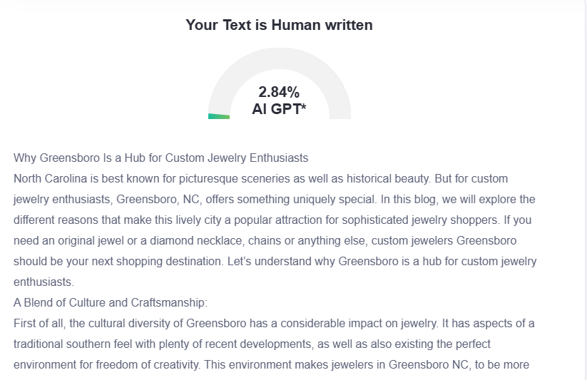

GMB
Nestled in vibrant Greensboro, Crystal Jewelers stands at the intersection of tradition and innovation, creating custom jewelry that tells your unique story. Our artists develop beautiful jewelry by working with premium materials from world-famous sources that they have gained skill in using for many years. From statement necklaces to intricate diamond designs, we transform your vision into wearable art. Greensboro's diverse cultural landscape inspires our creations, resulting in distinctive pieces that cannot be found elsewhere. We distinguish ourselves by giving you complete attention during the entire creation process of your custom product. Our high standards in quality, ethical business, and new ideas have made us the favorite spot for people from all over who want genuine custom jewelry in Greensboro. Our store provides a space that encourages individuals to showcase their unique style through luxury jewelry purchases. Whether reimagining family heirlooms or crafting engagement rings that symbolize your love story, Crystal Jewelers delivers unparalleled craftsmanship and attention to detail. We've proudly contributed to Greensboro's emergence as a jewelry hub through our commitment to excellence and creativity. Visit our store to see firsthand why Crystal Jewelers is considered the premier custom jewelry destination in Greensboro, where your most precious moments are transformed into timeless treasures.

